Formulae that are highlighted in green will be given in the exam, unless they are to be derived.

02 Mathematical Background

# Functions

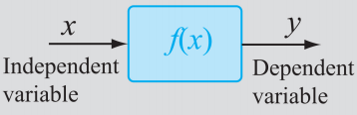

The span of $x$ is called the **domain**.

The span of $y$ is called the **range**.

The span can also be called an **interval**:

* Open interval: $]a,b[$ or $(a,b)$ $a>x>b$
* Closed interval: $[a,b]$ $a≥x≥b$

### Limit of a Function

For continuous functions:

$\lim_{x→a}f(x)=f(a)=L$

$f(x)$ may be discontinuous or singular at $a$. In these cases, the limit is said **not to exist**.

### Continuity of a Function

A function $f(x)$ at $x=a$ is said to be continuous if:

* $f(a)$ exists

$\lim_{x→a}f(x)=f(a)$

### The Intermediate Value Theorem

If both:

1. $f(x)$ is continuous in $[a,b]$
2. $M$ is any number between $f(a)$ and $f(b)$

then $∃c∈[a,b]$ such that $f(c)=M$.

### Derivatives of a Function

The derivative of a function $y=f(x)$ is denoted as either:

$\frac{dy}{dx}$

$\frac{df(x)}{dx}$

$f'(x)$

It is defined as:

$\frac{dy}{dx}│{}_{x=a}=f'(a)=\lim_{x→a}\frac{f(x)-f(a)}{x-a}$

$\frac{f(x)-f(a)}{x-a}$ is the slope of the secant connecting $(a,f(a))$ and $(x,f(x))$.

In the limit as $x→a$, we get a slope of tangent at $(a,f(a))$.

This slope is equivalent to the rate of change of $f(x)$ with respect to $x$ at $x=a$.

### The Chain Rule

$\frac{dy}{dx}=\frac{dy}{du}\frac{du}{dx}$

Example:

|  |
| --- |
| $f(x)={(sin x)}^{2}$ $u=sin x$ $f'(x)=\frac{dy}{dx}=\frac{dy}{du}\frac{du}{dx}=\frac{dy}{d(sin x)}\frac{d(sin x)}{dx}=2(sin x)*cos x=2 sin x cos x$ |

### The Product Rule

$\frac{du(x)v(x)}{dx}=u(x)\frac{dv(x)}{dx}+v(x)\frac{du(x)}{dx}$

Example:

|  |
| --- |
| $y=(x^{3}+7x-1)(5x+2)$ $u(x)=x^{3}+7x-1$ $\frac{du(x)}{dx}={3x}^{2}+7$ $v(x)=5x+2$ $\frac{dv(x)}{dx}=5$ $\frac{du(x)v(x)}{dx}=u(x)\frac{dv(x)}{dx}+v(x)\frac{du(x)}{dx}=(x^{3}+7x-1)(5)+(5x+2)({3x}^{2}+7)=...$ |

### The Mean Value Theorem (For Derivatives)

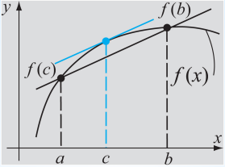

If $f(x)$ is a continuous function in $[a,b]$ and is differentiable in the open interval $]a,b[$, then $∃c∈]a,b[$ such that:

$f'(c)=\frac{f(b)-f(a)}{b-a}$

In other words, at some point in the interval, the slope of the tangent line will equal the slope of the secant line between $f(a)$ and $f(b)$.

### Integral / Antiderivative of a Function

If $f(x)=\frac{dF(x)}{dx}$ then:

* The **indefinite integral** of $f(x)$ is $F(x)$: $F(x)=\int{}f(x)dx$
* The **definite integral** of $f(x)$ is $I$: $I=\int_{a}^{b}{}f(x)dx$

Assuming $f(x)$ is defined and continuous over $[a,b]$ then:

$\int_{a}^{b}{}f(x)dx=\lim_{Δx_{i}→0}\sum_{i=1}^{n}{}f(c_{i})Δx_{i}$

### Fundamental Theorems of Calculus

$\int_{a}^{b}{}f(x)dx=F(b)-F(a)$

and

$\frac{d}{dx}(\int_{a}^{x}{}f(ζ)dζ)=f(x)$

### The Mean Value Theorem (For Integrals)

If $f(x)$ is continuous over $[a,b]$ then $∃c∈[a,b]$ such that:

$\int_{a}^{b}{}f(x)dx=f(c)(b-a)$

The **average value** of $f(x)$ over the interval is:

$〈f〉=\frac{1}{b-a}\int_{a}^{b}{}f(x)dx$

In other words, there must be some value $f(c)$ within the interval that takes on the average value of $f(x)$ over the interval $[a,b]$.

# Vectors

Vectors are quantities that have a **magnitude** and **direction**.

Scalars are quantities with **magnitude only**.

To denote the vector $V$ we write (or $V^{→}$ in these notes).

The **magnitude** of a vector is denoted $V$ or $\left|V\right|$.

A vector may be represented graphically as a **directed line segment**.

Projections of the vector onto each of the coordinate axes define the **components** of the vector.

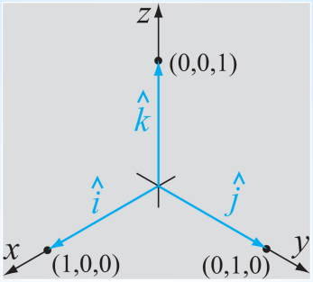

$\hat{i}$, $\hat{j}$ and $\hat{k}$ are the **unit vectors** in the $x$, $y$ and $z$ directions respectively.

A unit vector is a vector with a **magnitude of unity** in a particular direction:

$\hat{V}=\frac{V^{→}}{\left|V\right|}$

We can therefore write:

$V^{→}=V_{x}\hat{i}+V_{y}\hat{j}+V_{z}\hat{k}$

where $V_{x}\hat{i}$ is the $x$-component of $V^{→}$ (the projection of $V^{→}$ onto the $x$-axis) and so on.

A vector may be written by listing the **magnitudes of its components** in a row or column:

e.g. $V^{→}=\left[V_{x} V_{y} V_{z}\right]$

The **magnitude** of a vector in three-dimensional Cartension space is its **length**:

$\left|V^{→}\right|=\sqrt{{V_{x}}^{2}+{V_{y}}^{2}+{V_{z}}^{2}}$

The unit vector in the direction of $V^{→}$ is:

$\hat{V}=\frac{V^{→}}{\left|V^{→}\right|}=\frac{V_{x}\hat{i}+V_{y}\hat{j}+V_{z}\hat{k}}{\sqrt{{V_{x}}^{2}+{V_{y}}^{2}+{V_{z}}^{2}}}=l\hat{i}+m\hat{j}+n\hat{k}$

In mathematics, a vector is a set or list of numbers written in a row or column:

e.g. $\left[V\right]=\left[V_{1} V_{2} ... V_{n}\right]$

### Addition and Subtraction of Vectors

$V^{→}+U^{→}=\left[V_{i}+U_{i}\right]=\left[V_{1}+U_{1}, V_{2}+U_{2}, ..., V_{n}+U_{n}\right]$

$V^{→}-U^{→}=\left[V_{i}-U_{i}\right]=\left[V_{1}-U_{1}, V_{2}-U_{2}, ..., V_{n}-U_{n}\right]$

### Multiplication by a Scalar

${αV}^{→}=α\left[V^{→}\right]=\left[αV_{1}, αV_{2}, ..., αV_{n}\right]$

### Transpose of a Vector

If $V^{→}=\left[V_{1}, V_{2}, ..., V_{n}\right]$ then:

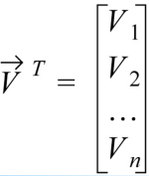

### Multiplication of Two Vectors

**Dot Product / Scalar Product**:

$V^{→}∙U^{→}=\left[V_{i}\right]\left[U_{i}\right]=V_{1}U_{1}+V_{2}U_{2}+...+V_{n}U_{n}$

or

$V^{→}∙U^{→}=\left|V^{→}\right|\left|U^{→}\right|cos θ$ (Multiply the magnitudes of both vectors and by $cos θ$)

**Cross Product / Vector Product**:

$W^{→}=V^{→}×U^{→}=V^{→}⊗U^{→}=\left|V^{→}\right|\left|U^{→}\right|sin θ \hat{w}$

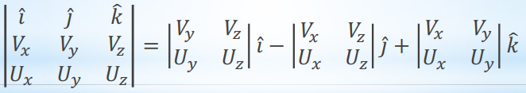

$=\left(V_{y}U_{z}-V_{z}U_{y}\right)\hat{i}-\left(V_{x}U_{z}-V_{z}U_{x}\right)\hat{j}+\left(V_{x}U_{y}-V_{y}U_{x}\right)\hat{k}$

### Linear Dependence and Independence on a Set of Vectors

A set of vectors $V_{1}^{→}, V_{2}^{→}, ..., V_{n}^{→}$ is said to be **linearly independent** if:

$α_{1}V_{1}^{→}+α_{2}V_{2}^{→}+...+α_{n}V_{n}^{→}=0$ is satisfied $iff α_{1}=α_{2}=...=α_{n}=0$.

Otherwise, the set of vectors is said to be **linearly dependent**.

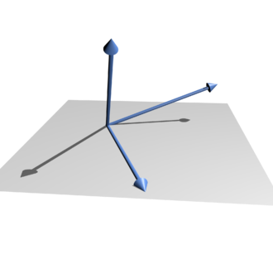

i.e. If one of the vectors in the set can be defined as a linear combination of the others, then the set of vectors is said to be linearly dependent.

### The Triangle Inequality

$\left|V^{→}+U^{→}\right|≤\left|V^{→}\right|+\left|U^{→}\right|$

# Matrices & Linear Algebra

A matrix is a rectangular array of numbers. The size of the matrix refers to the number of rows and columns that it contains.

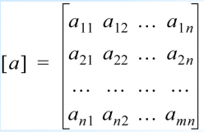

An element $a_{i j}$ refers to row $i$ and column $j$.

A **row vector** is a $1×n$ matrix.

A **column vector** is a $n×1$ matrix.

### Multiplication by a Scalar

If $\left[a\right]=\left[a_{i j}\right]$ is a matrix, and $α$ is a scalar, then $α\left[a\right]=\left[{αa}_{i j}\right]$ is obtained by **multiplying every element** of $\left[a\right]$ by $α$.

### Addition and Subtraction of Matrices

Matrices can only be added or subtracted if they are both of the **same size**.

This is done by adding / subtracting the **corresponding entries** of both matrices.

The resulting matrix $\left[c\right]$ is the same size where:

$\left[c_{i j}\right]=\left[a_{i j}\right]+\left[b_{i j}\right]$

$\left[c_{i j}\right]=\left[a_{i j}\right]-\left[b_{i j}\right]$

### Transpose of a Matrix

The transpose of a matrix is a matrix with the **rows and columns interchanged**.

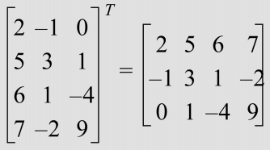

${\left[a\right]}^{T}=\left[a_{i j}^{T}\right]=\left[a_{j i}\right]$

### Multiplication of Matrices

The multiplication $\left[c\right]=\left[a\right]\left[b\right]$ is defined only if the numbers of columns of $\left[a\right]$ equals the number of rows of matrix $\left[b\right]$.

The resulting matrix $\left[c\right]$ has the same number of rows as $\left[a\right]$ and the same number of columns as $\left[b\right]$.

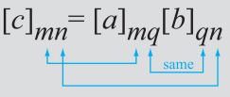

If $\left[a\right]$ is $m×q$ and $\left[b\right]$ is $q×n$ then $\left[c\right]$ is $m×n$.

$c_{i j}=\sum_{k=1}^{q}{}a_{i k}{ b}_{k j}$

For example:

|  |  |
| --- | --- |
| $c_{1 1}=a_{1 1}{ b}_{1 1}+a_{1 2}{ b}_{2 1}+a_{1 3}{ b}_{3 1}+a_{1 4}{ b}_{4 1}$ $c_{1 2}=a_{1 1}{ b}_{1 2}+a_{1 2}{ b}_{2 2}+a_{1 3}{ b}_{3 2}+a_{1 4}{ b}_{4 2}$ $c_{2 1}=a_{2 1}{ b}_{1 1}+a_{2 2}{ b}_{2 1}+a_{2 3}{ b}_{3 1}+a_{2 4}{ b}_{4 1}$ |  |

### Special Matrices

|  |  |
| --- | --- |
| **Square Matrix**:  Has the same number of columns as rows.  Entries $a_{i i}$ are known as the **diagonal elements**, and all others are the **off-diagonal elements**. |  |
| **Diagonal Matrix**: $\left[D\right]$ A square matrix with diagonal elements that are non-zero, and off-diagonal elements that are zero. |  |
| **Upper-Triangular Matrix**: $\left[U\right]$ A square matrix whose **sub-diagonal** entries are all zero. |  |
| **Lower-Triangular Matrix**: $\left[L\right]$ A square matrix whose **super-diagonal** entries are all zero. |  |
| **Identity Matrix**: $\left[I\right]$ A square matrix whose diagonal elements are all ones, and off-diagonal entries are all zero.  Any matrix multiplied by the identity matrix remains **unchanged**. $\left[a\right]\left[I\right]=\left[a\right]$ |  |
| **Zero Matrix**:  A matrix whose entries are all zero.  Any matrix multiplied by a zero matrix will yield a zero matrix. $\left[z\right]\left[a\right]=\left[z\right]$ |  |
| **Symmetric Matrix**:  A square matrix whose lower-diagonal entries mirror its upper-diagonal entries. $\left[a_{i j}\right]=\left[a_{j i}\right]$ The transpose of a symmetric matrix is the matrix itself. ${\left[a\right]}^{T}=\left[a\right]$ |  |

### Inverse of a Matrix

A matrix is invertible (its multiplicative inverse can be found) if there exists a square matrix $\left[b\right]$ of the same size such that $\left[a\right]\left[b\right]=\left[I\right]$.

$\left[a\right]{\left[a\right]}^{-1}={\left[a\right]}^{-1}\left[a\right]=\left[I\right]$

${\left[a\right]}^{-1}=\left[b\right]$

### Determinant of a Matrix

This is a useful quantity to determine if a matrix has an inverse.

$det(A)=\left|A\right|=\sum_{j}{}{(-1)}^{k}a_{1 j_{1}}a_{2 j_{2}}...{ a}_{n j_{n}}$

Example:

|  |
| --- |
|  |

### Cramer’s Rule and Solution to a System of Linear Equations

Given a set of $n$ simultaneous equations with $n$ unknowns:

|  |
| --- |
| $a_{11}x_{1}+a_{12}x_{2}+...+a_{1n}x_{n}=b_{1}$ $a_{21}x_{1}+a_{22}x_{2}+...+a_{2n}x_{n}=b_{2}$ $... + ... + ...+ ... =...$ $a_{n1}x_{1}+a_{n2}x_{2}+...+a_{nn}x_{n}=b_{n}$ |

The system of equations can be written compactly using matrices:

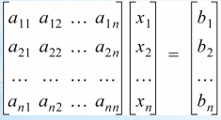

i.e. $\left[a\right]\left[x\right]=\left[b\right]$

Cramer’s Rule states that the solution for $\left[x\right]$, if it exists, is given by:

$x_{j}=\frac{det({a'}_{j})}{det(a)} for j=1,2,...,n$

where ${a'}_{j}$ is the matrix formed by replacing the th column of the matrix $\left[a\right]$ with the column vector $\left[b\right]$.

*Note*: ${\left[a\right]}^{-1}$ exists $iff det(a)≠0$

$det(a)=0$ if one or more columns or rows of $\left[a\right]$ are **not** linearly independent.

Example: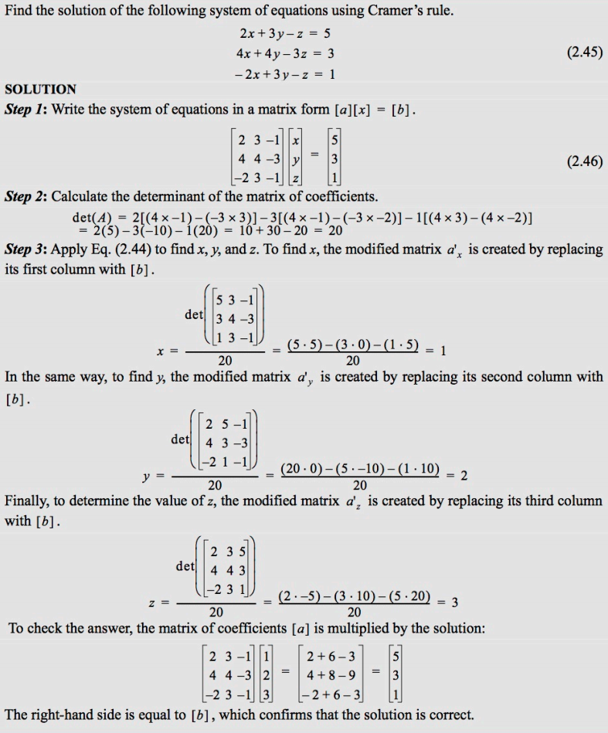

# Ordinary Differential Equations (ODEs)

An ordinary differential equation is one that contains:

1. **One dependent variable** (e.g. $y$).
2. **One independent variable** (e.g. $x$).
3. **Ordinary derivatives** of the dependent variable (as opposed to partial).

Examples:

|  |
| --- |
| $\frac{dy}{dx}=10x$ $c\frac{dx}{dt}+kx=-m\frac{d^{2}x}{dt^{2}}$ |

An ordinary differential equation is **nonlinear** if any of the **coefficients** are **functions of the dependent variable**.

Examples:

|  |
| --- |
| $\frac{d^{2}y}{dt^{2}}+sin y=4$ $y\frac{d^{2}y}{dt^{2}}+3y=8$ |

An ODE is said to be **homogenous** if the **coefficient of the independent variables is zero**. Otherwise, it is said to be nonhomogeneous.

Examples:

|  |
| --- |
| $\frac{dy}{dx}=10x$ is a **linear**, **nonhomogeneous** ODE. $\frac{d^{2}y}{dt^{2}}+sin y=4$ is a **nonlinear**, **homogeneous** ODE. |

The **order** of an ODE is the **highest derivative** that appears in the equation.

Example:

|  |
| --- |
| $\frac{d^{2}y}{dt^{2}}+sin y=4$ is a **second order** ODE. |

### Boundary Conditions & Initial Conditions

To eliminate integration constraints when solving a differential equation we apply **constraints**.

These are referred to as **boundary conditions** (solutions to the DE at particular points) and in the case of **time-dependent DEs**, **initial conditions** (or the solution to the DE at $t=0$).

Examples:

|  |
| --- |
| **Nonhomogeneous Linear First-Order ODE**: $\frac{dy}{dx}+P(x)y=Q(x)$ Multiply both sides of the equation by the following integrating factor: $u(x)=\int_{e}{}P(x)dx$ This gives: $\frac{d}{dx}(yμ)=Q(x)μ(x)$ Integrating both sides gives: $y(x)μ(x)=\int{}Q(x)μ(x)+C_{1}$ Dividing through by $μ(x)$ gives: $y(x)=\frac{1}{μ(x)}\int{}Q(x)μ(x)+\frac{C_{1}}{μ(x)}$ The constant of integration is determined from a constraint which is problem-dependent. |

|  |
| --- |
| **Homogeneous Linear Second-Order ODE**:  Consider: $\frac{d^{2}y}{dx^{2}}+b\frac{dy}{dx}+cy=0$ where $a$ and $b$ are constants.  The general solution to this equation is found by substituting $y=e^{sx}$.  The resulting equation is called the **characteristic equation**: $s^{2}+bs+c=0$ The solution is obtained from the quadratic formula: $s=\frac{-b±\sqrt{b^{2}-4c}}{2}$ The general solution is then: $y(x)=e^{-bx/2}\left[C_{1}e^{\frac{x}{2}\sqrt{b^{2}-4c}}{+C}_{2}e^{-\frac{x}{2}\sqrt{b^{2}-4c}}\right]$ If $b^{2}<4ac$ we get: $y(x)=e^{-bx/2}\left[C_{1}e^{\frac{i}{2}x\sqrt{b^{2}-4c}}{+C}_{2}e^{-\frac{i}{2}x\sqrt{b^{2}-4c}}\right]$ |

### Functions of Two or More Independent Variables

Consider the function:

$z=f(x,y)=\frac{x^{2}}{4}+\frac{y^{2}}{9}$

This is a function of two variables where $z$ is the dependent variable and $x$ and $y$ are the independent variables.

### The Partial Derivative

For $z=f(x,y)$, the first partial derivative of $f$ with respect to $x$ is denoted by $\frac{δf}{δx}$ or $f_{x}$ and is defined by:

$\frac{δf}{δx}=\lim_{Δx→0}\frac{f(x+Δx,y)-f(x,y)}{Δx}$

if the limit exists.

Also:

$\frac{δf}{δy}=\lim_{Δy→0}\frac{f(x,y+Δy)-f(x,y)}{Δy}$

The partial derivative with respect to a certain variable (say $x$) simply by treating (or holding) all other independent variables (say $y$ and $z$) to constants.

Example:

|  |
| --- |
| $z=f(x,y)=x^{2}+xy+y^{2}$ $\frac{δz}{δx}=2x+y$ $f_{y}(x)=x^{2}+xy+y^{2}$ $f_{a}(x)=x^{2}+xa+a^{2}$ |

The **total differential** (or exact differential) of a function of two variables, say $f(x,y)$ is given by:

$df=\frac{∂f}{∂x}dx+\frac{∂f}{∂y}dy$

Using the formula for the total differential we can state:

$\frac{df}{dt}=\frac{∂f}{∂x}\frac{dx}{dt}+\frac{∂f}{∂y}\frac{dy}{dt}$

where $x$ and $y$ are both functions of the independent variable $t$.

Consider $f(x,y)$ where $y=g(x)$ then:

$\frac{df}{dx}=\frac{∂f}{∂x}+\frac{∂f}{∂y}\frac{∂y}{∂x}$

Consider $f(x,y,z)$ where $z=h(x,y)$ then:

$\frac{∂f}{dx}│_{y}=\frac{∂f}{∂x}+\frac{∂f}{∂z}\frac{∂z}{∂x}│_{y}$

or

$\frac{∂f}{dx}=\frac{∂f}{∂x}+\frac{∂f}{∂z}\frac{∂z}{∂x}$

### The Jacobian

The Jacobian is a quantity that arises when solving **systems of nonlinear equations**.

Given $f_{1}(x,y)=a$ and $f_{2}(x,y)=b$ (where $a$ and $b$ are constants) then the **Jacobian matrix** is:

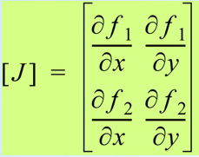

The **Jacobian determinant** or simply the **Jacobian** is:

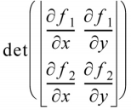

$=\left(\frac{∂f_{1}}{∂x}\right)\left(\frac{∂f_{2}}{∂y}\right)-\left(\frac{∂f_{1}}{∂y}\right)\left(\frac{∂f_{2}}{∂x}\right)$

In general:

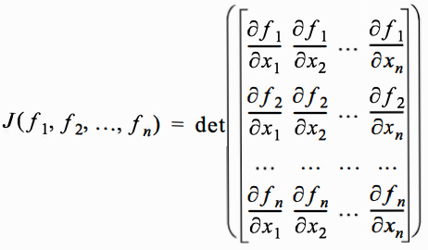

### Taylor Series Expansion of Functions

Used to represent a function as an **infinite power series**.

This can be useful when trying to **integrate** certain non-analytic functions since a truncated series may result in a good analytic **approximation** of the function.

It may also be used in approximating functions to make them more easily manipulated for certain purposes such as **increasing computational speed**.

Given a function $f(x)$ that is differentiable $n+1$ times in an interval containing $x=x_{0}$, Taylor’s theorem states that $∃ξ∈\left[x,x_{0}\right]$ such that:

$f(x)=f(x_{0})+(x-x_{0})\frac{df}{dx}│_{x=x_{0}}+\frac{{(x-x_{0})}^{2}}{2!}\frac{d^{2}f}{dx^{2}}│_{x=x_{0}}+\frac{{(x-x_{0})}^{3}}{3!}\frac{d^{3}f}{dx^{3}}│_{x=x_{0}}+...+\frac{{(x-x_{0})}^{n}}{n!}\frac{d^{n}f}{dx^{n}}│_{x=x_{0}}+R_{n}(x)$

where $R_{n}(x)$ called the **remainder** is given by:

$R_{n}=\frac{{(x-x_{0})}^{n+1}}{(n+1)!}\frac{d^{n+1}f}{dx^{n+1}}│_{x=ξ}$

The value of the remainder $R_{n}$ cannot actually be calculated since the value of $ξ$ is not known.

For $n=1$, Taylor’s theorem reduces to:

$f(x)=f(x_{0})+(x-x_{0})\frac{df}{dx}│_{x=ξ}$

or

$\frac{df}{dx}│_{x=ξ}=\frac{f(x)-f(x_{0})}{(x-x_{0})}$

which is a statement of the **mean value theorem for derivatives**.

Example:

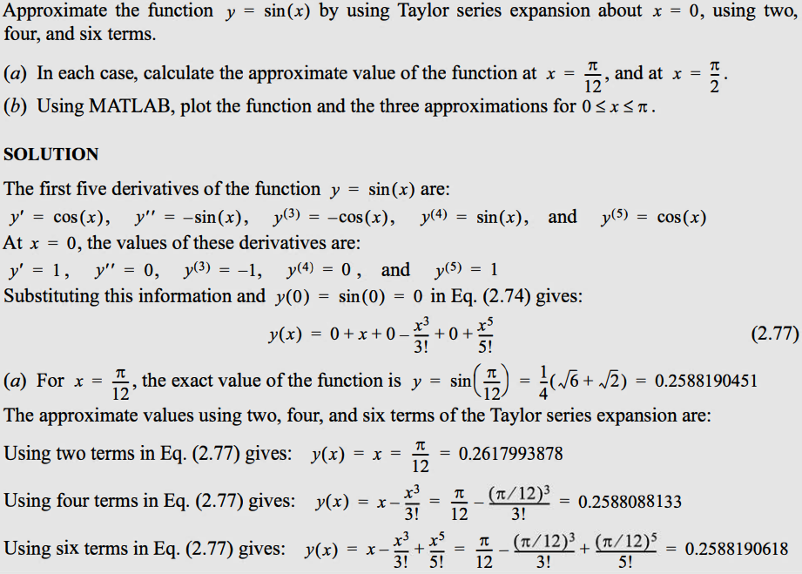

Matlab:

|  |
| --- |
| % Generate a linearly-spaced vector between 0 and pi with 100 elements x = linspace(0, pi, 100); y = sin(x); % Function we are approximating with Taylor series  % Terms of Taylor series y2 = x; % First two terms. y4 = y2 - (x.^3)/factorial(3); % .^ is element-wise power y6 = y4 + (x.^5)/factorial(5); % First six terms.  % Plot graph plot(x, y, 'k', ... % black line  x, y2, 'r', ... % ... allows multi-line functions  x, y4, 'g', ...  x, y6, 'b');   axis([0, 4, -2, 2]); % 0<=x<=4, -2<=y<=2  legend('sin(x)', ... % line 1  '2 terms', ... % line 2  '4 terms', ...  '6 terms');  xlabel('x'); ylabel('y'); |

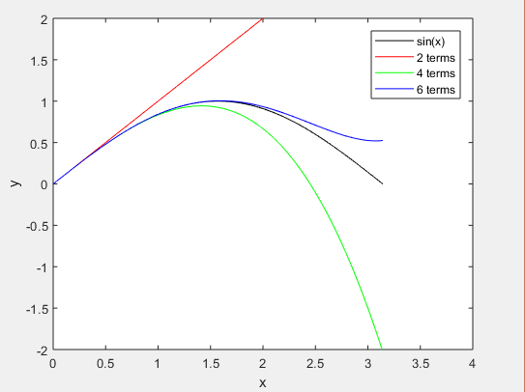

### Taylor Series for a Function of Two Variables

Taylor’s expansion for a function of two variables is done the same way as for a function of one independent variable, except that the differentiation involves **partial derivatives**.

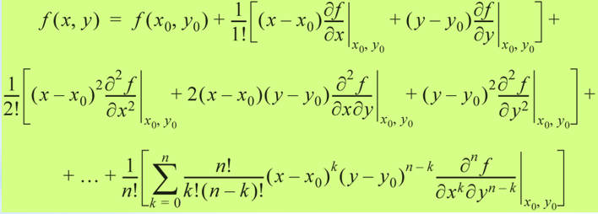

### Inner Product & Orthogonality

The **inner product** (scalar product or dot product) of two vectors $V^{→}$ and $U^{→}$ is denoted:

$〈V^{→}|U^{→}〉$ or $〈V^{→},U^{→}〉$ or $V^{→}∙U^{→}$

Say $V^{→}=V_{x}\hat{i}+V_{y}\hat{j}+V_{z}\hat{k}$ and $U^{→}=U_{x}\hat{i}+U_{y}\hat{j}+U_{z}\hat{k}$

Then:

$〈V^{→}|U^{→}〉=V^{→}∙U^{→}=\left|V^{→}\right|\left|V^{→}\right|cos θ=V_{x}U_{x}+V_{y}U_{y}+V_{z}U_{z}$

The vectors are said to be **orthogonal** to each other if:

$〈V^{→}|U^{→}〉=0$

and **parallel** if:

$〈V^{→}|U^{→}〉=1$

The inner product of two functions $f(x)$ and $g(x)$ over an interval $\left[a,b\right]$ is given by:

$〈f(x)|g(x)〉=\int_{a}^{b}{}f(x)g(x)dx$

Again, they are said to be orthogonal if:

$〈f(x)|g(x)〉=0$

The **sine** and **cosine** functions are orthogonal at all frequencies:

$〈sin(kx)|cos(mx)〉=\int_{-π}^{π}{}sin(kx)cos(mx)dx=0$ for both $k=m$ and $k≠m$

03 Solving Nonlinear Equations

An equation of one variable can be written in the form:

$f(x)=0$

A solution to the equation (a root of the equation) is a numerical value of $x$ that satisfies the equation.

Graphically, this is the point (or points) where the function $f(x)$ intersects the $x$-axis.

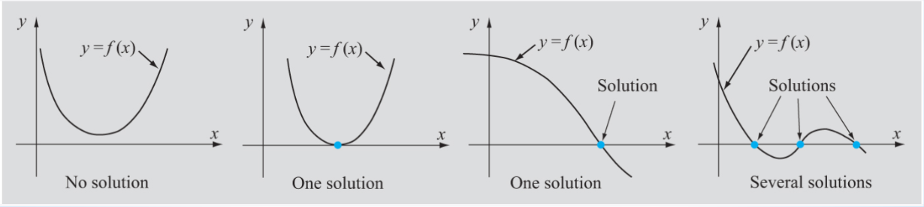

Sometimes the solutions can be obtained analytically (such as using the formula for solving a quadratic equation), but sometimes there is **no analytic solution** and the equation must be solved **numerically**.

A numerical solution of an equation $f(x)=0$ is a value of $x$ that satisfies the equation **approximately**.

When $x$ is substituted in the equation, the value of $f(x)$ is **close** to zero, but not exactly.

We will always have an error in our approximation. This error **must be quantified** as it tells us the range in which the exact solution lies.

### Estimation of Errors in Numerical Solutions

Let:

1. $x_{TS}$ be the true (exact) solution such that ${f(x}_{TS})=0$
2. $x_{NS}$ be the numerical solution such that ${f(x}_{NS})=ε$ where $ε$ is a small number.

### True Error

$TrueError=x_{TS}-x_{NS}$

In general $x_{TS}$ is **unknown** so we need to use other measures.

### Tolerance (in $f(x)$)

$ToleranceInf=\left|{f(x}_{TS})-{f(x}_{NS})\right|=\left|0-ε\right|=\left|ε\right|$

If it is known that the solution is in the domain $\left[a,b\right]$ then:

$x_{NS}=\frac{a+b}{2}$

plus or minus a tolerance of:

$\left|\frac{b-a}{2}\right|$

### True Relative Error

$TrueRelativeError=\left|\frac{x_{TS}-x_{NS}}{x_{TS}}\right|$

but since $x_{TS}$ is unknown we use the estimated relative error.

### Estimated Relative Error

When two numerical estimates for the solution are known (from multiple iterations):

$EstimatedRelativeError=\left|\frac{x_{NS}^{(n)}-x_{NS}^{(n-1)}}{x_{NS}^{(n)}}\right|$

When the numerical solution is close to the true solution then:

$x_{NS}^{(n)}-x_{NS}^{(n-1)}<<x_{NS}^{(n)}$

i.e. the difference $x_{NS}^{(n)}-x_{NS}^{(n-1)}$ is small compared to the value of $x_{NS}^{(n)}$.

The estimated relative error is approximately the same as the true relative error.

The methods for solving nonlinear equations are divided into:

1. Bracketing methods
2. Open methods

|  |  |
| --- | --- |
| **Bracketing Methods** | **Open Methods** |
| In **bracketing methods**, the **interval** containing the solution is identified.  The size of the interval is successively **reduced** until the distance between the endpoints is less that the desired accuracy of the solution. | In open methods, an **initial guess** is made at the solution before narrowing down the search through **further guesswork**.  Solutions that have a **higher error** than the current solution are **discarded**. |
| **Always** converge to a solution. | More **efficient**, but **may not** yield a solution. |
| **Examples**:   1. Bisection Method 2. Regula Falsi Method | **Examples**:   1. Newton’s Method 2. Secant Method 3. Fixed-Point Iteration |
|  |  |

All these methods assume that $f(x)$:

1. Is **continuous**.
2. Is **differentiable** over the appropriate interval.
3. Has a **solution**.

# Bracketing Methods

### 1) The Bisection Method

Used for finding the solution of $f(x)=0$ when it is known that the solution exists within a given interval $\left[a,b\right]$.

**Algorithm**:

1. Choose the **first interval** by finding points $a$ and $b$ such that a solution exists in this domain. $f(a)$ 
    and $f(b)$ have **different signs** so that .
2. The first estimate of the numerical solution is then:
3. Determine whether the true solution is between ( and ) or ( and b).  
   This is done by checking the sign of :
   1. If , then the true solution is between $a$ and $x_{NS1}$.
   2. If $f(a)f(x_{NS1})>0$, then the true solution is between $x_{NS1}$ and $b$.
4. Select the subinterval that contains the true solution.  
   *Go to step 2*.

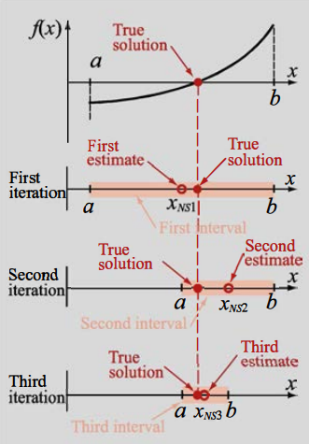

Matlab:

|  |
| --- |
| % Define an anonymous function f(x)=8-4.5(x-sin(x)) f = @ (x) 8 - 4.5*(x - sin(x));  % Define initial interval a<=x<=3 a = 2; b = 3;  maxIterations = 100; % Perform at most 100 iterations. tolerance = 1e-10; % Terminate after tolerance is reached.  % Make sure that initial interval is valid. if (f(a)*f(b)>0)  disp("Error, a and b are invalid bounds.")  disp(strcat("f(a)=", num2str(f(a))));  disp(strcat("f(b)=", num2str(f(b)))); end  % Perform Bisection method until either max iterations or tolerance are % reached. for i = 0 : maxIterations  mid = (a+b)/2;    % Stop iterating if within tolerance.  if abs(f(mid)) < tolerance  break;  end;    % Calculate new interval.  sign = f(a)*f(mid);  if (sign < 0)  b = mid;  else  a = mid;  end end  % Print results of x, f(x) and number of iterations. disp(strcat("x=", num2str(mid))); disp(strcat("f(x)=", num2str(f(mid)))); disp(strcat("iterations=", num2str(i))); |

### 2) The Regula Falsi Method

Approximates the solution by calculating the intercept of the line containing $f(a)$ and $f(b)$ with the interval $\left[a,b\right]$ where the solution is known to exist.

The equation of the line that connects $(a, f(a))$ and $(b, f(b))$ is:

$y=\frac{f(b)-f(a)}{b-a}(x-b)+f(b)$ ($y=mx+c$)

Its intercept with the $x$-axis is determined by subbing $y=0$ into the previous formula and solving the equation for $x$:

$x_{NS}=\frac{af(b)-bf(a)}{f(b)-f(a)}$

**Algorithm**:

1. Choose the **first interval** by finding points $a$ and $b$ such that a solution exists in this domain. $f(a)$ 
    and $f(b)$ have **different signs** so that .
2. The first estimate of the numerical solution is then:
3. Determine whether the true solution is between ( and ) or ( and b).  
   This is done by checking the sign of :
   1. If , then the true solution is between $a$ and $x_{NS1}$.
   2. If $f(a)f(x_{NS1})>0$, then the true solution is between $x_{NS1}$ and $b$.
4. Select the subinterval that contains the true solution.  
   *Go to step 2*.

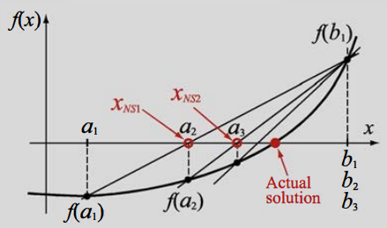

# Open Methods

### 1) Newton’s Method (Newton-Raphson Method)

Approximates the solution initially as the intercept of the tangent to the function, at an initial guess-point, with the $x$-axis.

Subsequent iterations approximate the solution as the intercept of the tangent to the function, at the point defined by the previous estimate, with the $x$-axis.

This algorithm does **not** necessarily converge.

**Algorithm**:

1. Choose $(x_{1}, f(x_{1}))$ as a starting point near the solution.
2. For the first iteration, the slope of the tangent at $(x_{1}, f(x_{1}))$ is given by: $f'(x_{1})=\frac{f(x_{1})-0}{x_{1}-x_{2}}$ 
    (rise over run, slope between $(x_{1}, f(x_{1}))$ and $(x_{2}, 0)$)  
     
   Solving for $x_{2}$ gives: $x_{2}=x_{1}-\frac{f(x_{1})}{f'(x_{1})}$
3. Generalising the previous formula, we can **repeat step 3**: $x_{i+1}=x_{i}-\frac{f(x_{i})}{f'(x_{i})}$

Newton’s method may not converge, in particular if $f(x)≈0$ in the vicinity of the solution.

If $f'(x)$ and $f''(x)$ are continuous, $f(x)≠0$ at the solution and if the starting value $(x_{1}, f(x_{1}))$ is near the solution, then the method converges.

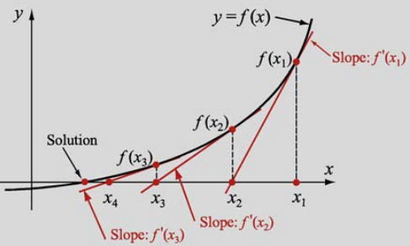

Matlab:

|  |
| --- |
| % Define an anonymous function f(x)=8-4.5(x-sin(x)) f = @ (x) 8 - 4.5*(x - sin(x)); % f(x) dfdx = @ (x) -4.5 + 4.5*cos(x); % f’(x)  % Define starting point (x, f(x)) x = 5;  maxIterations = 100; % Perform at most 100 iterations. tolerance = 1e-10; % Terminate after tolerance is reached.  % Perform Newton's method until either max iterations or tolerance are % reached. for i = 0 : maxIterations  % Calculate numerical solution.  x = x - f(x) / dfdx(x);    % Stop iterating if within tolerance.  if abs(f(x)) < tolerance  break;  end; end  % Print results of x, f(x) and number of iterations. disp(strcat("x=", num2str(x))); disp(strcat("f(x)=", num2str(f(x)))); disp(strcat("iterations=", num2str(i))); |

### 2) The Secant Method

Similar to Newton’s Method, however we use a **secant** to the function instead of a tangent.

This means we initially need **two points** near the solution.

**Algorithm**:

1. Choose $(x_{1}, f(x_{1}))$, $(x_{2}, f(x_{2}))$ as starting points near the solution.
2. For the first iteration, the slope of the secant line is given by: $\frac{f(x_{1})-f(x_{2})}{x_{1}-x_{2}}=\frac{f(x_{2})-0}{x_{2}-x_{3}}$ 
     
     
   Solving for $x_{3}$ gives: $x_{3}=x_{2}-\frac{f(x_{2})(x_{1}-x_{2})}{f(x_{1})-f(x_{2})}$
3. Generalising the previous formula, we can **repeat step 3**: $x_{i+1}=x_{i}-\frac{f(x_{i})(x_{i-1}-x_{i})}{f(x_{i-1})-f(x_{i})}$

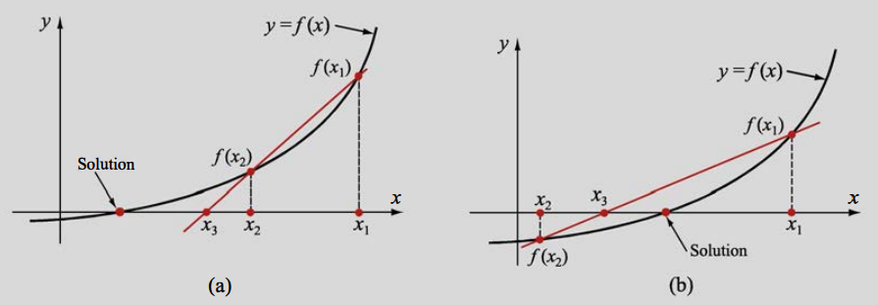

Matlab:

|  |
| --- |
| % Define an anonymous function f(x)=8-4.5(x-sin(x)) f = @ (x) 8 - 4.5*(x - sin(x)); % f(x)  % Define starting points (x1, f(x1)), (x2, f(x2)) x1 = 6; x2 = 5;  maxIterations = 100; % Perform at most 100 iterations. tolerance = 1e-10; % Terminate after tolerance is reached.  % Perform Secant method until either max iterations or tolerance are % reached. for i = 0 : maxIterations  % Calculate numerical solution.  new = x2 - (f(x2)*(x1-x2)) / (f(x1)-f(x2));  x1 = x2;  x2 = new;    % Stop iterating if within tolerance.  if abs(f(x2)) < tolerance  break;  end; end  % Print results of x, f(x) and number of iterations. disp(strcat("x2=", num2str(x2))); disp(strcat("f(x2)=", num2str(f(x2)))); disp(strcat("iterations=", num2str(i))); |

### 3) The Fixed-Point Iteration Method

Used for solving an equation of the form:

$f(x)=0$

This function is written in the form:

$x=g(x)$.

This equation holds true at the **intersection** of the line $y=x$ and the function $y=g(x)$.

This intersection is called the fixed point.

The problem boils down to obtaining the $x$-coordinate of this point of intersection.

**Algorithm**:

1. Take a value of $x$ near the solution (the solution is the point of intersection between the line $y=x$ and the function $y=g(x)$) .  
   This is our first estimate of the solution.
2. Find $g(x)$.
3. Use this $y$-ordinate to obtain an $x$-ordinate using the line $y=x$.  
   *Go to step 2*.

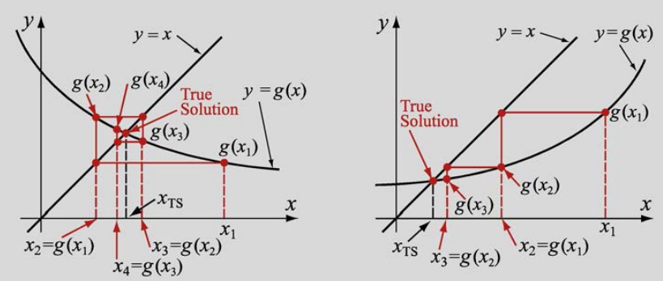

This method is prone to diverge depending on the manner in which $x=g(x)$ is expressed.

If the function is slowly varying such that in the neighbourhood of the solution:

$\left|g'(x)\right|<1$

then the process will converge to the correct solution.

**Example**:

Considering $xe^{0.5x}+1.2x-5=0$

We can write $x=g(x)$ a number of different ways:

$x=\frac{5-xe^{0.5x}}{1.2}$

$x=\frac{5}{xe^{0.5x}+1.2}$

$x=\frac{5-1.2x}{e^{0.5x}}$

Only when expressed as the second option do we get:

$\left|g'(x)\right|<1; x=1,2$

Matlab:

|  |
| --- |
| % f(x) = 8-4.5(x-sin(x)) = 0 % rewrite into form x = g(x)  % Define an anonymous function g(x) g = @ (x) sin(x) + 8/4.5;  % Define starting x value x = 5;  maxIterations = 100; % Perform at most 100 iterations. tolerance = 1e-10; % Terminate after tolerance is reached.  % Perform Secant method until either max iterations or tolerance are % reached. for i = 0 : maxIterations  % Calculate numerical solution.  y = g(x);  x = y;    % Stop iterating if within tolerance.  if abs(g(x) - x) < tolerance  break;  end; end  % Print results of x, g(x) and number of iterations. disp(strcat("x=", num2str(x))); disp(strcat("g(x)=", num2str(g(x)))); disp(strcat("iterations=", num2str(i))); |

# Systems of Nonlinear Equations

A system of nonlinear equations consists of **two or more nonlinear equations** that have to be solved simultaneously.

### 1) Newton’s Method (For Systems of Nonlinear Equations)

A system of two equations with two unknowns $x$ and $y$ can be written as:

$f_{1}(x,y)=0$

$f_{2}(x,y)=0$

The solution process begins by choosing an **estimated solution $x_{1}$**  and $y_{1}$.

If $x_{2}$ and $y_{2}$ are the true (unknown) solutions to the system and are sufficiently close to $x_{1}$ and $y_{1}$, then the values of $f_{1}$ and $f_{2}$ at $x_{2}$ and $y_{2}$ can be expressed using a **Taylor series expansion** of the functions $f_{1}(x,y)=0$ and $f_{2}(x,y)=0$ about ${(x}_{1},y_{1})$.

$f_{1}(x_{2},y_{2})=f_{1}(x_{1},y_{1})+(x_{2}-x_{1})\frac{∂f_{1}}{∂x}│_{x_{1},y_{1}}+(y_{2}-y_{1})\frac{∂f_{1}}{∂y}│_{x_{1},y_{1}}+...$

$f_{2}(x_{2},y_{2})=f_{2}(x_{1},y_{1})+(x_{2}-x_{1})\frac{∂f_{2}}{∂x}│_{x_{1},y_{1}}+(y_{2}-y_{1})\frac{∂f_{2}}{∂y}│_{x_{1},y_{1}}+...$

Since $x_{2}$ and $y_{2}$ are close to $x_{1}$ and $y_{1}$, approximate values for $f_{1}(x_{2},y_{2})$ and $f_{2}(x_{2},y_{2})$ can be calculated by **neglecting the higher-order terms**.

Since $f_{1}(x_{2},y_{2})=0$ and $f_{2}(x_{2},y_{2})=0$, our Taylor-expanded equations can be rewritten as:

$\frac{∂f_{1}}{∂x}│_{x_{1},y_{1}}Δx+\frac{∂f_{1}}{∂x}│_{x_{1},y_{1}}Δy={-f}_{1}(x_{1},y_{1})$

$\frac{∂f_{2}}{∂x}│_{x_{1},y_{1}}Δx+\frac{∂f_{2}}{∂x}│_{x_{1},y_{1}}Δy={-f}_{2}(x_{1},y_{1})$

where $Δx=x_{2}-x_{1}$ and $Δy=y_{2}-y_{1}$.

The system can be solved using Cramer’s rule:

$Δx=\frac{{-f}_{1}(x_{1},y_{1})\frac{∂f_{2}}{∂y}│_{x_{1},y_{1}}+f_{2}(x_{1},y_{1})\frac{∂f_{1}}{∂y}│_{x_{1},y_{1}}}{J(f_{1}(x_{1},y_{1}),{ f}_{2}(x_{1},y_{1}))}$

$Δy=\frac{{-f}_{2}(x_{1},y_{1})\frac{∂f_{2}}{∂x}│_{x_{1},y_{1}}+f_{1}(x_{1},y_{1})\frac{∂f_{1}}{∂x}│_{x_{1},y_{1}}}{J(f_{1}(x_{1},y_{1}),{ f}_{2}(x_{1},y_{1}))}$

where:

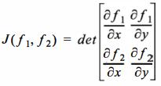

$J(f_{1},f_{2})$ is the Jacobian. Once $Δx$ and $Δy$ are known, the values of $x_{2}$ and $y_{2}$ are calculated by:

$x_{2}=x_{1}+Δx$

$y_{2}=y_{1}+Δx$

**Newton’s method** can be generalised for a system of $n$ nonlinear equations which have the form:

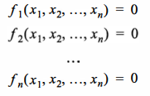

which gives:

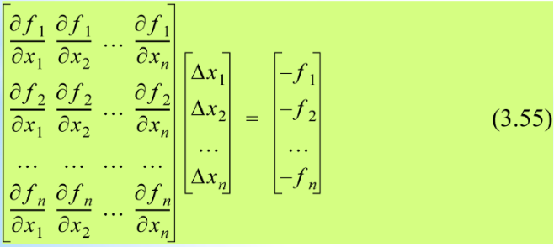

**Algorithm**:

1. Estimate an initial solution: $x_{1,i}, x_{2,i}, x_{3,i}, ...$
2. Solve equation 3.55 for $Δx_{1}, Δx_{2}, Δx_{3}, ...$
3. Calculate a new estimate of the solution using: $x_{1,i+1}=x_{1,i}+Δx_{1}$ $x_{2,i+1}=x_{2,i}+Δx_{2}$ $...$ $x_{n,i+1}=x_{n,i}+Δx_{n}$
4. Repeat until the desired accuracy is reached.

Newton’s method does not necessarily converge, but when it does it does so quickly.

The Jacobian must be non-zero and the initial estimates must be close to the solution.

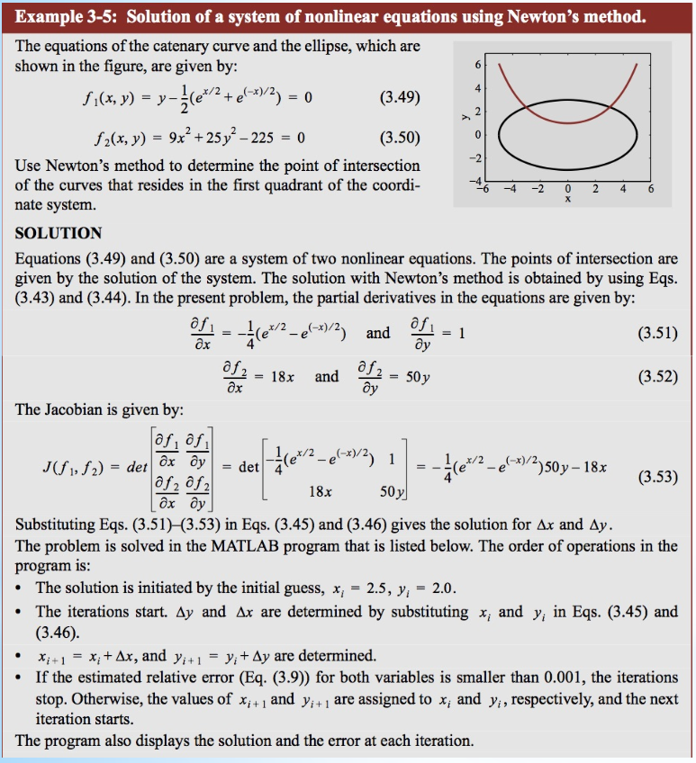

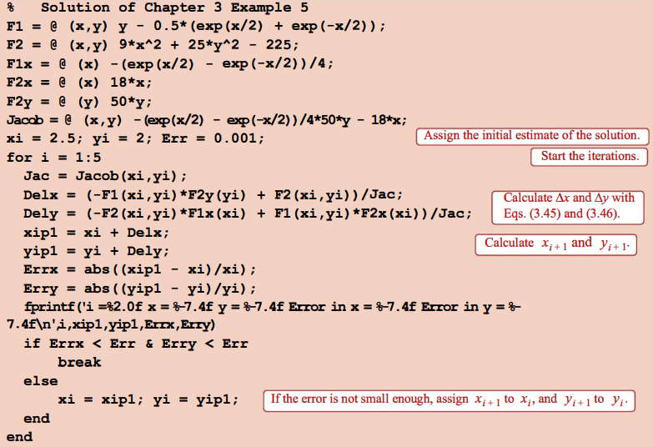

### 2) Fixed-Point Method (For Systems of Nonlinear Equations)

**Algorithm**:

1. We begin with: $f_{1}(x_{1}, x_{2}, ..., x_{n})=0$ $f_{2}(x_{1}, x_{2}, ..., x_{n})=0$ $...$ $f_{n}(x_{1}, x_{2}, ..., x_{n})=0$
2. This system can be rewritten in the form: $x_{1}=g_{1}(x_{1}, x_{2}, ..., x_{n})$ $x_{2}=g_{2}(x_{1}, x_{2}, ..., x_{n})$ $...$ $x_{n}=g_{n}(x_{1}, x_{2}, ..., x_{n})$
3. We then choose an initial estimate for the solution $x_{1,1}, x_{2,1},{ x}_{3,1} ...$ which is substituted into the RHS of our rewritten system.  
   The LHS is our new second estimate of the solution.
4. We continue this process until a desired accuracy is reached.

The fixed-point iteration method will converge under the following (but not necessary) conditions:

1. If the functions $g$ and their derivatives are continuous in the neighbourhood of the solution.
2. If $\sum_{i}{}\left|\frac{∂g_{n}}{∂x_{i}}\right|≤1$
3. The initial estimate is close to the solution.

04 Solving a System of Linear Equations

The general form of a system of $n$ linear algebraic equations is:

|  |
| --- |
| $a_{11}x_{1}+a_{12}x_{2}+...+a_{1n}x_{n}=b_{1}$ $a_{21}x_{1}+a_{22}x_{2}+...+a_{2n}x_{n}=b_{2}$ $... + ... + ...+ ... =...$ $a_{n1}x_{1}+a_{n2}x_{2}+...+a_{nn}x_{n}=b_{n}$ |

Which can be written as:



### Methods for Solving Systems of Linear Equations

These equations can be solved with **analytic**, **direct** or **iterative** methods. However, analytic methods such as Kramer’s rule become impossible to compute when the number of equations is large.

|  |  |
| --- | --- |
| **Direct methods** | **Iterative methods** |
| The solution is calculated using an efficient numerical algorithm which performs **arithmetic operations** on equations. | An initial approximate solution is assumed and is then used in an iterative process to obtain **successively more-accurate** results. |

# Direct Methods

In direct methods, the initial system of equations is manipulated into an **equivalent** system of equations that can be easily solved.

Three systems of linear equations that can be **easily solved** are:

1. Upper triangular form
2. Lower triangular form
3. Diagonal form

### Upper-Triangular Form

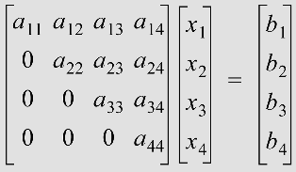

This equation can be easily solved by **back-substitution**:

1. We start with the last equation and solve for $x_{n}$.
2. Knowing $x_{n}$, we can then solve for $x_{n-1}$ and so on.

The general form for the solution using back-substitution is:

|  |
| --- |
| $x_{n}=\frac{b_{n}}{a_{nn}}$ $x_{i}=\frac{b_{i}-\sum_{j=i+1}{}a_{ij}x_{j}}{a_{ii}} i=n-1, n-2, ..., 1$ |

### Lower-Triangular Form

Likewise, a lower-triangular form can be solved using forward substitution.

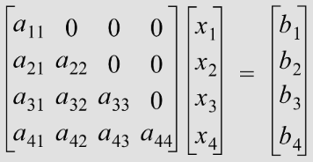

### Gaussian Elimination

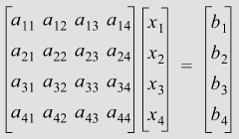

Here, the full set of linear equations is manipulated to be in **upper-triangular form**, which can then be solved using back-substitution.

**Algorithm**:

1. We take the **first equation**, called the **pivot equation**. $a_{11}$ 
    is called the pivot coefficient or **pivot element**.  
   The pivot element is always a diagonal element.  
     
   To eliminate the term $a_{21}x_{1}$, we multiply the pivot equation by $m_{21}=\frac{a_{21}}{a_{11}}$.  
   The resulting equation is subtracted from the second equation thus eliminating $x_{1}$.  
   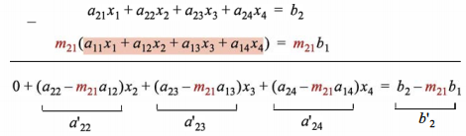  
   Note that the **pivot equation remains unchanged**.  
   The second equation now has new coefficients.  
     
   The same process is used to eliminate $x_{1}$ from all subsequent equations using $m_{i 1}=\frac{a_{i1}}{a_{11}}$ for the th equation giving:  
   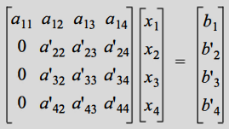
2. The process is now repeated operating on the third and subsequent equations using the second as the pivot equation and $a_{22}$ as the pivot element.  
   This eliminates $x_{2}$ from these equations.  
     
   Continuing in this fashion yields an upper-triangular system which can be solved using back-substitution.

Problems with zero or near-zero pivoting elements can be remedied by **changing the order** of the system of equations such that **no zero or near-zero elements appear on the diagonal**.

This process is known as **pivoting**.

### Gauss-Jordan Elimination

Gauss-Jordan elimination is similar to Gaussian elimination except that:

1. The pivot equation is normalised by **dividing all the terms** in the pivot equation by the **pivot coefficient**. This makes the pivot coefficient equal to 1.
2. The pivot equation is used to eliminate the off-diagonal terms in **all equations**.

The result is a **diagonal matrix** that can be easily solved.

Pivoting applies as with Gaussian elimination.

### LU Decomposition

In this method, we begin with the equation to be solved:

$\left[a\right]\left[x\right]=\left[b\right]$ where $\left[x\right]$ and $\left[b\right]$ are vectors.

Then $\left[a\right]=\left[L\right]\left[U\right]$

where $\left[L\right]$ and $\left[U\right]$ are lower and upper triangular matrices respectively.

We then write:

$\left[L\right]\left[U\right]\left[x\right]=\left[b\right]$

We then say:

$\left[U\right]\left[x\right]=\left[y\right]$

and

$\left[L\right]\left[y\right]=\left[b\right]$

$\left[L\right]\left[y\right]=\left[b\right]$ is then first solved for $\left[y\right]$ thus enabling $\left[U\right]\left[x\right]=\left[y\right]$ to be solved for $\left[x\right]$.

The advantage of this method is that $\left[L\right]\left[U\right]\left[x\right]=\left[b\right]$ can be easily solved by back and forward substitution.

### LU Decomposition Using The Gaussian Elimination Procedure

When the Gaussian Elimination procedure is applied to a matrix $\left[a\right]$, the elements of the matrices $\left[L\right]$ and $\left[U\right]$ are actually calculated.

The upper-triangular matrix $\left[U\right]$ is obtained at the **end** of the Gaussian Elimination procedure.

The lower-triangular matrix $\left[L\right]$ is a matrix with 1s as its diagonal elements and the multipliers $m_{i j}$ that multiply the pivot equation as its off-diagonal elements.

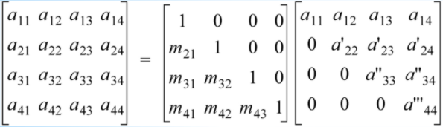

### LU Decomposition Using Crout’s Method

Crout’s method is particularly advantageous since we do not have to use vector $\left[b\right]$ at all, which means that we can solve for **multiple $\left[b\right]$** s once $\left[L\right]$ and $\left[U\right]$ have been determined.

In Crout’s method, the LU decomposition matrix has the form:

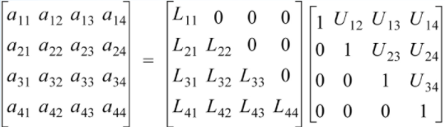

Executing the matrix multiplication on the RHS gives:

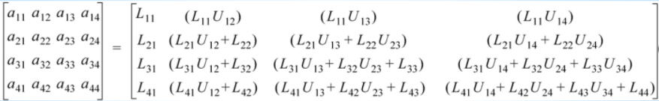

This equation is then solved by **equating** the elements of the product with that of matrix $\left[a\right]$.

In general:

1. Calculate the **first column** of $\left[L\right]$ using: $for i=1,2,...,n$ $L_{i 1}=a_{i 1}$
2. Substitute 1s in the **diagonal** of $\left[U\right]$: $for i=1,2,...,n$ $U_{i i}=1$
3. Calculate the elements of the **first row** of $\left[U\right]$**except** for $U_{1 1}$: $for j=2,...,n$ $U_{1 j}=\frac{a_{1 j}}{L_{1 1}}$
4. Then, calculate: $for j=2,...,i$ $L_{i j}=a_{i j}-\sum_{k=1}^{j-1}{}L_{i k}U_{k j}$ $for j=(i+1),(i+2)...,n$ $U_{i j}=\frac{a_{i j}-\sum_{k=1}^{j-1}{}L_{i k}U_{k j}}{L_{i i}}$

### Inverse of a Matrix

This is the most advantageous since it can easily be reused.

Consider:

$\left[a\right]{\left[a\right]}^{-1}={\left[a\right]}^{-1}\left[a\right]=\left[I\right]$

For $\left[x\right]={\left[a\right]}^{-1}$ we have:

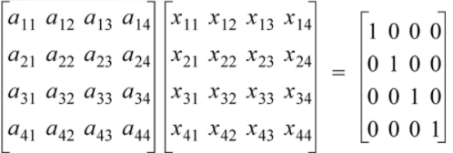

We then have:



Solving these four systems of equations gives the four columns of ${\left[a\right]}^{-1}$.

Among other methods, this can be done by **Gauss-Jordan elimination** and by **LU decomposition**.

### Inverse of a Matrix by LU Decomposition & Gauss-Jordan Elimination

We obtain each column of the inverse matrix by solving the system of equations.

This can be done by **Gauss-Jordan elimination** or by **LU decomposition** on each of the four equations.

# Iterative Methods

For the Jacobi and Gauss-Seidel iterative methods, the system of equations is written in **explicit form**:

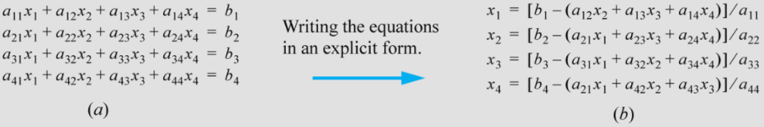

The idea is to **assume an initial solution** for $\left[x\right]$, and then **recursively substitute** these values in to the RHS of the above explicit form and so obtain new estimates for $\left[x\right]$.

$x_{i}=\frac{1}{a_{i i}}\left[b_{i}-\sum_{j=1, j≠i}^{j=n}{}a_{i j}x_{j}\right]$ $i=1,2,...,n$**(4.51)**

A sufficient (but not necessary) **condition for convergence** is:

$\left|a_{i i}\right|>\sum_{j=1, j≠i}^{j=n}{}\left|a_{i j}\right|$

### The Jacobi Iterative Method

An **initial solution** for $\left[x\right]$ is chosen. If no information is available then $\left[x\right]=0$.

The values for $\left[x\right]$ are substituted into the RHS of the explicit representation of the system of equations and a new estimate for $\left[x\right]$ is found. This process is repeated recursively.

That is:

${x_{i}}^{(k+1)}=\frac{1}{a_{i i}}\left[b_{i}-\sum_{j=1, j≠i}^{j=n}{}a_{i j}{x_{j}}^{(k)}\right]$ $i=1,2,...,n$

The process is continued until the absolute value of the estimated relative error of all unknowns is less than some predetermined value:

$\left|\frac{{x_{i}}^{(k+1)}-{x_{i}}^{(k)}}{{x_{i}}^{(k)}}\right|<ε$ $i=1,2,...,n$**(4.55)**

### The Gauss-Seidel Iterative Method



**Algorithm**:

1. **First iteration**:  
   To begin with, all unknowns $x_{j}$ except for $x_{1}$ are initialised with some approximate values. These can be zero if approximate values are unknown. $x_{i}=\frac{1}{a_{i i}}\left[b_{i}-\sum_{j=1, j≠i}^{j=n}{}a_{i j}x_{j}\right]$ $i=1,2,...,n$
     
    **(4.51 again)**  
     
   Using these values, with $i=1$ in equation (4.51), we calculate $x_{1}$.  
   With $i=2$ in equation (4.51), we calculate a new value for $x_{2}$ and so on.
2. **Second iteration**:  
   The next iteration uses $i=1$ in equation (4.51), where we calculate a new value for $x_{1}$.  
   With $i=2$ in equation (4.51), we calculate a new value for $x_{2}$ and so on.

These iterations are repeated until:

$\left|\frac{{x_{i}}^{(k+1)}-{x_{i}}^{(k)}}{{x_{i}}^{(k)}}\right|<ε$ $i=1,2,...,n$**(4.55 again)**

Mathematically, the Gauss-Seidel algorithm can be written:

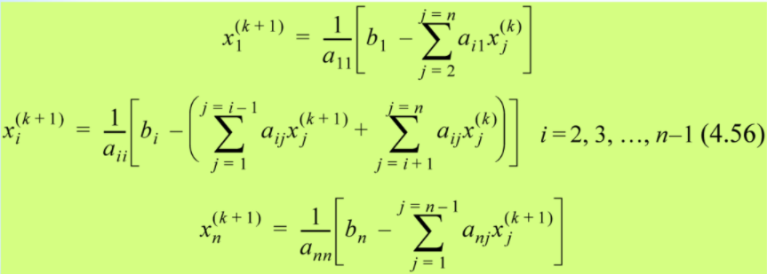

The Gauss-Seidel algorithm **converges faster** than the Jacobi method.

Like the Jacobi method, the sufficient but not necessary condition for convergence is that $\left[a\right]$ is diagonally dominant.

### Tridiagonal Systems of Equations

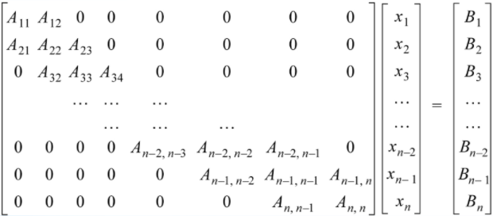

These can be readily solved using previous methods but many elements of $\left[a\right]$ are zero.

This means more storage space and many redundant zero multiplications and additions.

The **Thomas algorithm** is a “common sense” approach to the problem.

Instead of performing Gaussian elimination on $\left[a\right]$ as a whole, we store the **diagonal** and **off-diagonal** entries as **separate vectors**. We then apply **Gaussian elimination** as before.

### Error & Residual

Consider the equation $\left[a\right]\left[x\right]=\left[b\right]$

The **true error** is the vector $\left[e\right]$:

$\left[e\right]=\left[x_{TS}\right]-\left[x_{NS}\right]$*(TS = True Solution and NS = Numerical solution)*

But because $\left[x_{TS}\right]$ cannot be calculated in general, we instead use the **residual error $\left[r\right]$** :

$\left[r\right]=\left[a\right]\left[x_{TS}\right]-\left[a\right]\left[x_{NS}\right]=\left[b\right]-\left[a\right]\left[x_{NS}\right]$

$⇒\left[e\right]={\left[a\right]}^{-1}\left[r\right]$

The smaller the elements in $\left[r\right]$ the better $\left[x_{NS}\right]$ satisfies the equation. However, this does not necessarily tell us how close $\left[x_{NS}\right]$ is to $\left[x_{TS}\right]$.

# Norms

The norm of a vector or matrix is a number that in some way indicates collectively the **size** of the vector or matrix **elements**.

There are various definitions for the norm of a vector $\left[v\right]$ or matrix $\left[a\right]$.

We will concern ourselves with the **Euclidean 2-norm** on this course.

**Vector norms**:

1. The **infinity norm** ($l_{∞} norm$): ${\left|\left|v\right|\right|}_{∞}=max\left|v_{i}\right|$ $1≤i≤n$
2. The **1-norm** ($l_{1} norm$): ${\left|\left|v\right|\right|}_{1}=\sum_{i=1}^{n}{}\left|v_{i}\right|$
3. The **Euclidean 2-norm** ($l_{2} norm$): ${\left|\left|v\right|\right|}_{2}={(\sum_{i=1}^{n}{}v_{i}^{2})}^{1/2}$

The Euclidean 2-norm is also referred to as the **magnitude of the vector $\left[v\right]$** .

**Matrix norms**:

1. The **infinity norm** ($l_{∞} norm$):  
   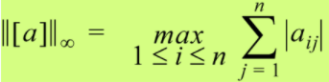
2. The **1-norm** ($l_{1} norm$):  
   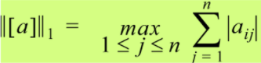
3. The **2-norm** ($l_{2} norm$): ${\left|\left|\left[a\right]\right|\right|}_{2}=max(\frac{\left|\left|\left[a\right]\left[v\right]\right|\right|}{\left|\left|\left[v\right]\right|\right|})$ 
    where $\left[v\right]$ is an **eigenvector** of $\left[a\right]$.
4. The **Euclidean norm**: ${\left|\left|\left[a\right]\right|\right|}_{Euclidean}={(\sum_{i=1}^{n}{}\sum_{j=1}^{n}{}a_{i j}^{2})}^{1/2}$ 
    *(i.e. The root of the sum of squares of the elements.)*

### Properties of Norms

1. The norm of a vector or matrix $\left[a\right]$, denoted $\left|\left|a\right|\right|$, is a **positive quantity** and is equal to zero iff $\left[a\right]=0$.
2. $\left|\left|a\left[a\right]\right|\right|=\left|a\right|\left|\left|\left[a\right]\right|\right|∀a$ This means that $\left|\left|\left[-a\right]\right|\right|=\left|\left|\left[a\right]\right|\right|≥0$
$\left|\left|a\left[x\right]\right|\right|=\left|\left|\left[a\right]\right|\right|\left|\left|x\right|\right|$

4. **The triangle inequality**: $\left|\left|\left[a+b\right]\right|\right|≤\left|\left|\left[a\right]\right|\right|+\left|\left|b\right|\right|$

### Using Norms to Determine Error Bounds

It can be shown that:

$\frac{1}{\left|\left|\left[a\right]\right|\right|\left|\left|{\left[a\right]}^{-1}\right|\right|}≤\frac{\left|\left|\left[r\right]\right|\right|}{\left|\left|\left[b\right]\right|\right|}≤\frac{\left|\left|\left[e\right]\right|\right|}{\left|\left|\left[x_{TS}\right]\right|\right|}≤\left|\left|{\left[a\right]}^{-1}\right|\right|\left|\left|\left[a\right]\right|\right|\frac{\left|\left|\left[r\right]\right|\right|}{\left|\left|\left[b\right]\right|\right|}$

This useful result gives an upper and lower bound to error relative to the true solution.

### The Condition Number of a Matrix

This tells us **how stable the solution** to a system of equations is.

This number shows how a small perturbation in $\left[a\right]$ will affect the solution. If the condition number is much **greater** than 1, then a small perturbation in $\left[a\right]$ will **greatly** affect the solution.

In this case, the matrix $\left[a\right]$ is said to be **ill-conditioned**.

By contrast, if a small perturbation in $\left[a\right]$ does **not** affect the solution greatly, then $\left[a\right]$ is said to be **well-conditioned**.

The condition number of a matrix $\left[a\right]$ is given by:

$Cond\left[a\right]=\left|\left|\left[a\right]\right|\right|\left|\left|{\left[a\right]}^{-1}\right|\right|$

For example, take the following system of equations:

|  |
| --- |
| $6x_{1}-2x_{2}=10$ $11.5x_{1}-3.85x_{2}=17$ |

The solution of this system is:

$x_{1}=45, x_{2}=130$

If we now change $a_{22}$ slightly to $3.84$, then:

$x_{1}=110, x_{2}=325$

It is clear that $\left[a\right]$ is **ill-conditioned**. In fact it has a condition number greater than 1500 regardless of which norm is used.

05 Eigenvalues and Eigenvectors

For a given square matrix $\left[a\right]$, the number $λ$ is an **eigenvalue** of the matrix if:

$\left[a\right]\left[u\right]=λ\left[u\right]$**(5.1)**

The vector $\left[u\right]$ is a common vector called the **eigenvector associated with the eigenvalue $λ$** .

There are usually **more than one** eigenvalue and eigenvector. For an $n×n$ matrix, there are $n$ eigenvalues and an infinite number of eigenvectors.

In general:

$Lu=λu$**(5.2)**

where $L$ is some mathematical operator.

Equation (5.2) is a general statement of an eigenvalue problem where $λ$ is the eigenvalue associated with the operator $L$.

For example, consider:

$\frac{d^{2}y}{dx^{2}}=k^{2}y$

where:

* $L$ is the second derivative with respect to $x$
* $y$ is the **eigenfunction**
* $k^{2}$ is the **eigenvalue** associated with $L$

We will concern ourselves with **matrix operations** only.

### Finding Eigenvalues and Eigenvectors

$\left[a\right]\left[u\right]=λ\left[u\right]$**(5.1 again)**

Equation (5.1) can be rewritten as:

$\left[a-λI\right]\left[u\right]=0$

If $\left[a-λI\right]$ has an inverse, then $\left[u\right]=0$.

If on the other hand $\left[a-λI\right]$ has no inverse, then a non-trivial solution for $\left[u\right]$ is possible.

Another way of stating this problem is to use **Cramer’s rule**.

$\left[a-λI\right]$ has no inverse (it is singular) if:

$det\left[a-λI\right]=0$

This equation is known as the **characteristic equation** for $\left[a\right]$.

The characteristic equation for $\left[a\right]$ yields a polynomial equation in $λ$ whose roots are the eigenvalues.

Once the eigenvalues are known then the eigenvectors $\left[u\right]$ can be determined by substituting the eigenvalues one at a time into equation (5.1) and solving for $\left[u\right]$.

This process is relatively straightforward for small matrices, but for large matrices we need to use **numerical methods** such as the **power method** or the **QR factorisation method**.

### The Basic Power Method

This method is an iterative procedure for determining the **largest real eigenvalue** and **corresponding eigenvector** of a matrix.

**Proof**:

|  |
| --- |
| Let $A$ be an $n×n$ matrix with eigenvalues which:   1. Are not necessarily distinct. 2. Satisfy the relations   The eigenvalue $λ_{1}$, which is the **largest in magnitude**, is known as the **dominant eigenvalue** of the matrix $A$.  Assume that the associated eigenvectors $v_{1}, v_{2}, v_{3}, ..., v_{n}$ are **linearly independent**, and therefore form a basis for $R^{n}$.  It should be noted that **not all matrices** have eigenvalues and eigenvectors which satisfy the conditions we have assumed here.  Let $x^{(0)}$ be a **nonzero** element of $R^{n}$. Since the eigenvectors of $A$ form a basis for $R^{n}$, it follows that $x^{(0)}$ can be written as a **linear combination** of $v_{1}, v_{2}, v_{3}, ..., v_{n}$.  That is, there exists **constants $α_{1}, α_{2}, α_{3}, ..., α_{n}$**  such that: $x^{(0)}={α_{1}v}_{1}+α_{2}v_{2}+α_{3}v_{3}+...+ {α_{n}v}_{n}$ Next, construct the sequence of vectors $\left\{x^{(m)}\right\}$ according to the rule $x^{(m)}=Ax^{(m-1)}$ for $m≥1$.  By **direct calculation** we find that: $x^{(1)}=Ax^{(0)}={α_{1}(Av}_{1})+α_{2}(Av_{2})+α_{3}(Av_{3})+...+ {α_{n}(Av}_{n})$ $={α_{1}(λ_{1}v}_{1})+α_{2}(λ_{2}v_{2})+α_{3}(λ_{3}v_{3})+...+ {α_{n}(λ_{n}v}_{n})$ $x^{(2)}=Ax^{(1)}=A^{2}x^{(0)}={α_{1}(A^{2}v}_{1})+α_{2}(A^{2}v_{2})+α_{3}(A^{2}v_{3})+...+ {α_{n}(A^{2}v}_{n})$ $={α_{1}({λ_{1}}^{2}v}_{1})+α_{2}({λ_{2}}^{2}v_{2})+α_{3}({λ_{3}}^{2}v_{3})+...+ {α_{n}({λ_{n}}^{2}v}_{n})$ and **in general**: $x^{(m)}=Ax^{(m-1)}=...=A^{m}x^{(0)}={α_{1}(A^{m}v}_{1})+α_{2}(A^{m}v_{2})+α_{3}(A^{m}v_{3})+...+ {α_{n}(A^{m}v}_{n})$ $={α_{1}({λ_{1}}^{m}v}_{1})+α_{2}({λ_{2}}^{m}v_{2})+α_{3}({λ_{3}}^{m}v_{3})+...+ {α_{n}({λ_{n}}^{m}v}_{n})$ In deriving these expressions, we have made repeated use of the relation ${Av}_{j}=λ_{j}v_{j}$, which follows from the fact that $v_{j}$ is an **eigenvector** associated with the **eigenvalue $λ_{j}$** .  Factoring ${λ_{1}}^{m}$ from the RHS of the equation for $x^{(m)}$ gives: $x^{(m)}={λ_{1}}^{m}\left[α_{1}v_{1}+α_{2}{(\frac{λ_{2}}{λ_{1}})}^{m}v_{2}+α_{3}{(\frac{λ_{3}}{λ_{1}})}^{m}v_{3}+...+α_{n}{(\frac{λ_{n}}{λ_{1}})}^{m}v_{n}\right]$ **(1)**  By assumption, for each $j$, so as $m→∞$.  It therefore follows that: |

|  |
| --- |
| Since any nonzero constant times an eigenvector is still an eigenvector associated with the same eigenvalue, we see that the scaled sequence $\left\{x^{(m)}/{λ_{1}}^{m}\right\}$ converges to an eigenvector associated with the **dominant eigenvalue** provided that $α_{1}≠0$.  Furthermore, convergence toward the eigenvector is **linear** with asymptotic error constant .  An approximation for the dominant eigenvalue of A can be obtained from the sequence $\left\{x^{(m)}\right\}$ as follows:  Let $i$ be an index for which ${x_{i}}^{(m-1)}≠0$, and consider the ratio of the th element from the vector $x^{(m)}$ to the th element from $x^{(m-1)}$.  By equation (1): $\frac{{x_{i}}^{(m)}}{{x_{i}}^{(m-1)}}=\frac{{λ_{1}}^{m}α_{1}v_{1, i}\left[1+O({(λ_{2}/λ_{1})}^{m})\right]}{{λ_{1}}^{m-1}α_{1}v_{1, i}\left[1+O({(λ_{2}/λ_{1})}^{m-1})\right]}=λ_{1}\left[1+O({(λ_{2}/λ_{1})}^{m-1})\right]$ ,  provided that $v_{1, i}≠0$ where $v_{1, i}$ denotes the th element from the vector $v_{1}$.  Hence the ratio $x^{(m)}/{x_{1}}^{(m-1)}$ converges towards the **dominant eigenvalue**, and the convergence is **linear** with asymptotic rate constant . |

### The Basic Power Method Algorithm

**Algorithm**:

1. Choose a column vector ${\left[x\right]}_{i}$ of length $n$. The vector can be any non-zero vector.
2. Multiply this vector ${\left[x\right]}_{i}$ by $\left[a\right]$. This gives a column vector ${\left[x\right]}_{i+1}$
3. Normalise this column vector.
4. *Go to step 2* with ${\left[x\right]}_{i+1}→{\left[x\right]}_{i}$
5. Continue with *steps 2 - 4* until a desired accuracy is reached for both the **eigenvalue** and **eigenvector**.

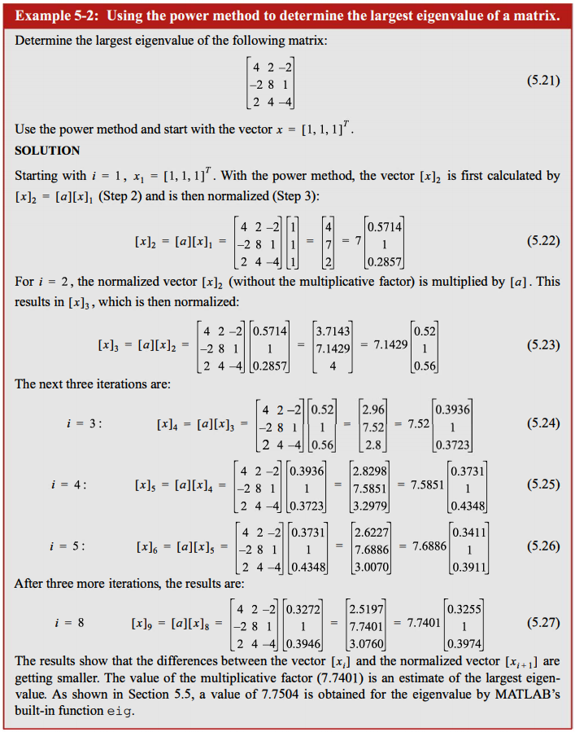

### The Inverse Power Method

This method is used for finding the **smallest** eigenvalue by applying the power method to ${\left[a\right]}^{-1}$.

The eigenvalues of ${\left[a\right]}^{-1}$ are the reciprocals of the eigenvalues of $\left[a\right]$.

This can be seen as follows:

|  |  |
| --- | --- |
| $\left[a\right]\left[x\right]=λ\left[x\right]$ Then: ${\left[a\right]}^{-1}\left[a\right]\left[x\right]={\left[a\right]}^{-1}λ\left[x\right]$ Hence: $\left[x\right]=λ{\left[a\right]}^{-1}\left[x\right]$ or ${\left[a\right]}^{-1}\left[x\right]=\frac{1}{λ}\left[x\right]$ This shows that $\frac{1}{λ}$ is an eigenvalue of ${\left[a\right]}^{-1}$. | *where $λ$ is the eigenvalue associated with the eigenvector $\left[x\right]$* |

Thus the Inverse Power Method can be used to find the largest eigenvalue of ${\left[a\right]}^{-1}$, which is the smallest eigenvalue of $\left[a\right]$.

**Algorithm**:

1. Choose a column vector ${\left[x\right]}_{i}$ of length $n$. The vector can be any non-zero vector.
2. Multiply this vector ${\left[x\right]}_{i}$ by ${\left[a\right]}^{-1}$. This gives a column vector ${\left[x\right]}_{i+1}$
3. Normalise this column vector and multiply it by ${\left[a\right]}^{-1}$ again: ${\left[x\right]}_{i+1}={\left[a\right]}^{-1}{\left[x\right]}_{i}$ 
     
     
   To avoid calculating ${\left[a\right]}^{-1}$, we use: $\left[a\right]{\left[x\right]}_{i+1}={\left[x\right]}_{i}$ 
     
     
   This can be solved for ${\left[x\right]}_{i+1}$ using, for example, LU Decomposition.
4. *Go to step 2* with ${\left[x\right]}_{i+1}→{\left[x\right]}_{i}$
5. Continue with *steps 2 - 4* until a desired accuracy is reached for both the **eigenvalue** and **eigenvector**.

### The Shifted Power Method

Given $\left[a\right]\left[x\right]=λ\left[x\right]$, then if $λ_{1}$ is the largest (or smallest) eigenvalue obtained using the Power Method (or Inverse Power Method), then the eigenvalues of a new shifted matrix formed by $\left[a-λI\right]$ are:

$α=0, λ_{2}-λ_{1},{ λ}_{3}-λ_{1}, ...,{ λ}_{n}-λ_{1}$

The reason for this is as follows:

$\left[a-λI\right]\left[x\right]=α\left[x\right]$

where the $α$ s are the eigenvalues of $\left[a-λI\right]$.

But also $\left[a\right]\left[x\right]=λ\left[x\right]$, so:

$(λ-λ_{1})\left[x\right]=α\left[x\right]$

where $λ=λ_{1}, λ_{2}, λ_{3}, ..., λ_{n}$

**Algorithm**:

1. Determine the **largest eigenvalue $λ_{1}$**  of $\left[a\right]$ using the Power Method.
2. Determine the **largest eigenvalue $α_{2}$**  of the shifted matrix $\left[a-λI\right]$ using the power method.  
   Then $α_{2}=λ_{2}-λ_{1}$ from which $λ_{3}$ can be determined.
3. Continue in this fashion until **all the eigenvalues** of $\left[a\right]$ are determined.  
   This is done in a total of $n$ steps where $\left[a\right]$ is an $n×n$ matrix.

The Shifted Power Method is an **inefficient process**. A preferred method for obtaining all eigenvalues of a matrix is the QR Factorisation Method.

### The QR Factorisation Method

Some definitions:

|  |
| --- |
| Two square matrices $\left[a\right]$ and $\left[b\right]$ are **similar** if: $\left[a\right]={\left[c\right]}^{-1}\left[b\right]\left[c\right]$ where $\left[c\right]$ is an **invertible matrix**. $\left[a\right]$ and $\left[b\right]$ have the **same eigenvalues**. |
| A matrix is **orthogonal** if: ${\left[a\right]}^{-1}={\left[a\right]}^{T}$ |
| A matrix is **symmetric** if: $\left[a\right]={\left[a\right]}^{T}$ |
| The **eigenvalues** of an **upper-triangular matrix** are its **diagonal elements**. |

QR Factorisation is used to find **all the eigenvalues** of a matrix.

We begin with the matrix ${\left[a\right]}_{1}$, whose eigenvalues are to be determined.

**Iteration 1**:

Let ${\left[a\right]}_{1}={\left[Q\right]}_{1}{\left[R\right]}_{1}$

where:

* ${\left[Q\right]}_{1}$ is an **orthogonal** matrix
* ${\left[R\right]}_{1}$ is an **upper-triangular** matrix

We now define ${\left[a\right]}_{2}={\left[R\right]}_{1}{\left[Q\right]}_{1}$

But ${\left[R\right]}_{1}={\left[Q\right]}_{1}^{-1}{\left[a\right]}_{1}={\left[Q\right]}_{1}^{T}{\left[a\right]}_{1}$

So we can write:

${\left[a\right]}_{2}={\left[Q\right]}_{1}^{T}{\left[a\right]}_{1}{\left[Q\right]}_{1}$

This means that ${\left[a\right]}_{1}$ and ${\left[a\right]}_{2}$ are similar, thus having the **same eigenvalues**.

**Iteration 2**:

We now write ${\left[a\right]}_{2}={\left[Q\right]}_{2}{\left[R\right]}_{2}$

Then define ${\left[a\right]}_{3}={\left[R\right]}_{2}{\left[Q\right]}_{2}$ where ${\left[R\right]}_{2}={\left[Q\right]}_{2}^{-1}{\left[a\right]}_{2}={\left[Q\right]}_{2}^{T}{\left[a\right]}_{2}$ so that ${\left[a\right]}_{3}={\left[Q\right]}_{2}^{T}{\left[a\right]}_{2}{\left[Q\right]}_{2}$ as in the first iteration.

These iterations continue until the sequence of matrices ${\left[a\right]}_{n-1}$ generates results in an **upper-triangular matrix** whose eigenvalues are its **diagonal elements** which are the same as the eigenvalues of ${\left[a\right]}_{1}$.

We now obtain ${\left[Q\right]}_{k}$ and ${\left[R\right]}_{k}$ ( $\left[Q\right]$ and $\left[R\right]$ for the th iteration).

To do this, we use the **Householder matrix** that has the form:

$\left[H\right]=\left[I\right]-\frac{2}{{\left[v\right]}^{T}\left[v\right]}\left[v\right]{\left[v\right]}^{T}$

where $\left[I\right]$ is the $(n×n)$ identity matrix and $\left[v\right]$ is an $n$-element column vector given by:

$\left[v\right]=\left[c\right]+{\left|\left|c\right|\right|}_{2}\left[e\right]$

where:

${\left|\left|c\right|\right|}_{2}=\sqrt{c_{1}^{2}+c_{2}^{2}+...+c_{2}^{2}}$

Note that ${\left[v\right]}^{T}\left[v\right]$ is a **scalar**, but $\left[v\right]{\left[v\right]}^{T}$ is an $(n×n)$ matrix.

The **Householder matrix** is both **symmetric** and **orthogonal**. This means that:

$\left[H\right]={\left[H\right]}^{T}={\left[H\right]}^{-1}$

Hence $\left[a\right]=\left[H\right]\left[b\right]\left[H\right]$ yields a matrix $\left[b\right]$ that is similar to $\left[a\right]$.

### QR Factorisation

Factoring the $(n×n)$ matrix $\left[a\right]$ into an orthogonal matrix $\left[Q\right]$ and an upper-triangular matrix $\left[R\right]$ such that $\left[a\right]=\left[Q\right]\left[R\right]$ is done in $n-1$ steps.

**Step 1**:

We choose $\left[c\right]$ to be the first column of $\left[a\right]$:

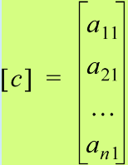

The vector $\left[e\right]$ is defined as:

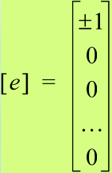

The first element of $\left[e\right]$ is $+1$ if the first element of $\left[c\right]$ is positive. Otherwise, it is negative.

Now we have enough information to calculate ${\left[H\right]}^{-1}$.

The matrix $\left[a\right]$ is factored into ${\left[Q\right]}^{(1)}{\left[R\right]}^{(1)}$ where:

${\left[Q\right]}^{(1)}={\left[H\right]}^{(1)}$ and ${\left[R\right]}^{(1)}={\left[H\right]}^{(1)}\left[a\right]$

The matrix ${\left[Q\right]}^{(1)}$ is orthogonal because ${\left[H\right]}^{(1)}$ is orthogonal.

${\left[R\right]}^{(1)}$ is a matrix with zeroes as the elements in the first column below the diagonal.

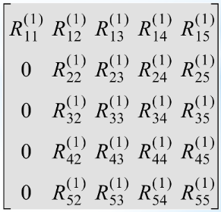

**Step 2**:

The vector $\left[c\right]$ is defined as the second column of the ${\left[R\right]}^{(1)}$ matrix with its first element set to zero:

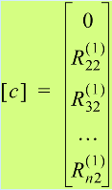

The vector $\left[e\right]$ is:

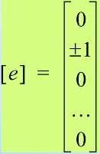

The second element of $\left[e\right]$ is $+1$ if the second element of $\left[c\right]$ is positive. Otherwise, it is negative.

Like before in *step 1*, a new Householder matrix ${\left[H\right]}^{(2)}$ is constructed.

We factor the matrix $\left[a\right]$ into ${\left[Q\right]}^{(2)}{\left[R\right]}^{(2)}$ where:

${\left[Q\right]}^{(2)}={\left[Q\right]}^{(1)}{\left[H\right]}^{(2)}$ and ${\left[R\right]}^{(2)}={\left[H\right]}^{(2)}{\left[R\right]}^{(1)}$

The matrix ${\left[Q\right]}^{(2)}$ is orthogonal because ${\left[H\right]}^{(2)}$ is orthogonal.

${\left[R\right]}^{(2)}$ is a matrix of zeros as the elements in the second column below the diagonal.

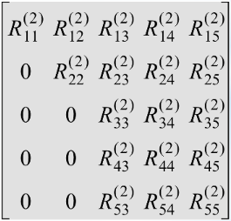

**Step 3**:

Moving to the third column of $\left[a\right]$, the vectors $\left[c\right]$ and $\left[e\right]$ are defined as:

|  |  |
| --- | --- |
|  |  |

where the sign rule applies as before.

${\left[R\right]}^{(3)}$ is then:

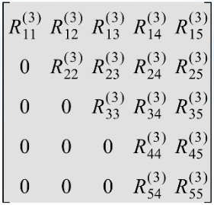

We continue in this latter fashion until ${\left[R\right]}^{(n-1)}$ is **upper-triangular**.

Then we have:

$\left[a\right]={\left[Q\right]}^{n-1}{\left[R\right]}^{n-1}$

This completes the factorisation of $\left[a\right]$.

**Algorithm**:

1. Factor ${\left[a\right]}_{1}$ into an orthogonal matrix ${\left[Q\right]}_{1}$ and an upper triangular matrix ${\left[R\right]}_{1}$.  
   This is done in $n-1$ steps using a Householder matrix such that: ${\left[a\right]}_{1}={\left[Q\right]}_{1}{\left[R\right]}_{1}$
2. Calculate: ${\left[a\right]}_{2}={\left[R\right]}_{1}{\left[Q\right]}_{1}$
3. *Repeat steps 1 and 2* until ${\left[a\right]}_{n-1}$ is reached.  
   At this point, ${\left[a\right]}_{n-1}$ is upper-triangular and so its eigenvalues (which are the same as those of $\left[a\right]$) appear on its diagonal.

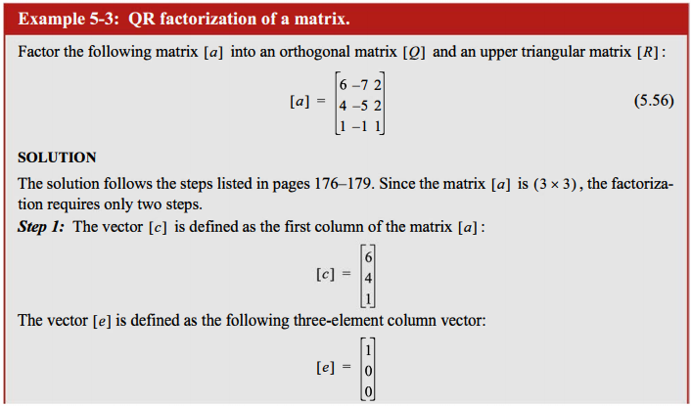

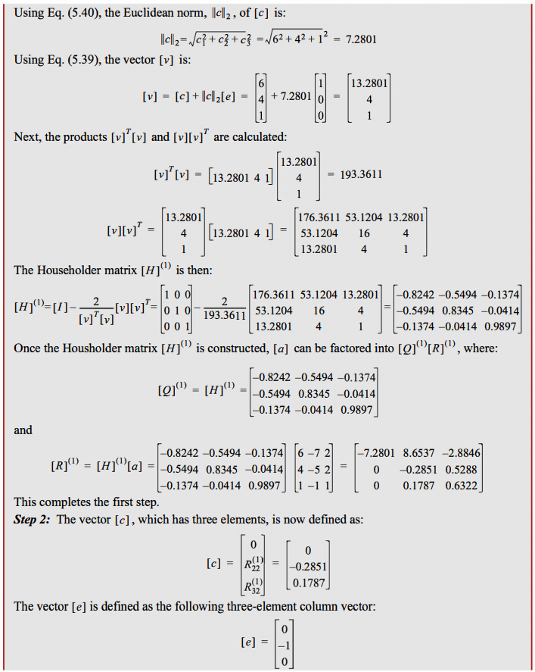

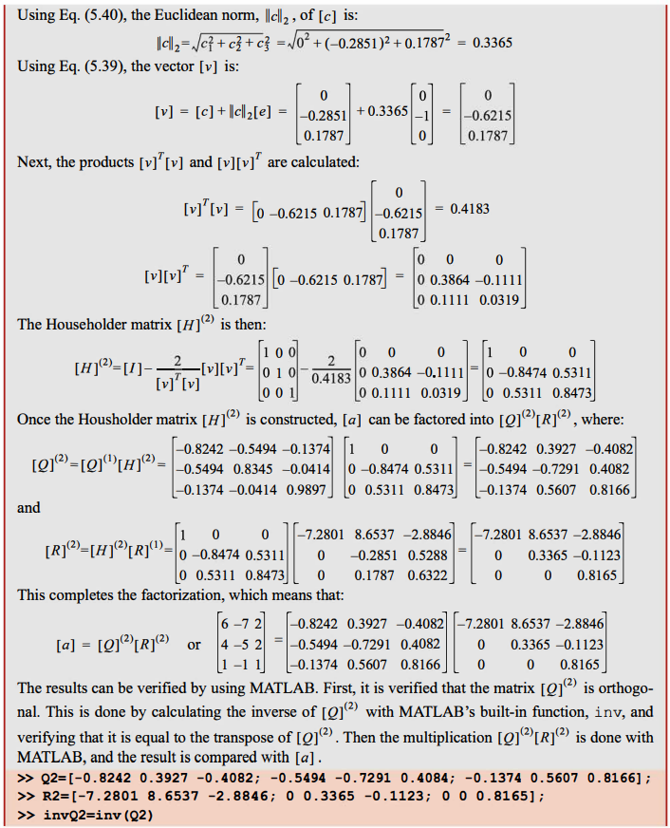

Google Docs is getting sluggish AF, so the rest of the notes will be in “All Notes 2/2”.